git and github tasks

- Install git.

To check the git version after install use command “git –version”
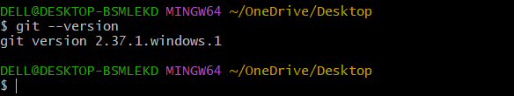

- Create a repo in github with README.md and .ignore file.

Created a repository in github with name Git-tasks
Added the files in that repo (REDME.md and .gitignore)
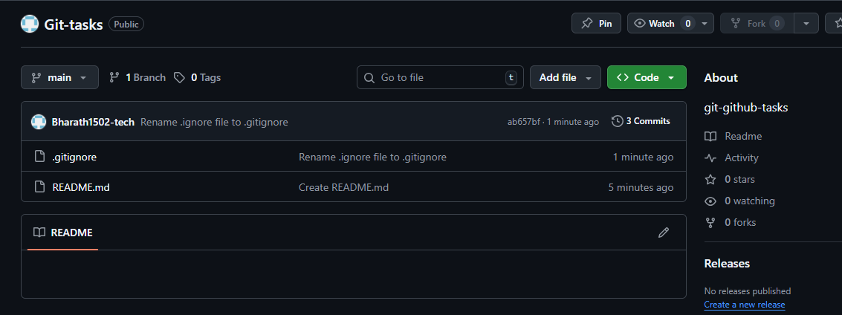

3 Clone the created repo to local.
To clone the created repo to local use command “git clone SSH Url”
The directory from the central repo will be clone to local repo
Go to created directory which created in github so that we can list the files created in directory.
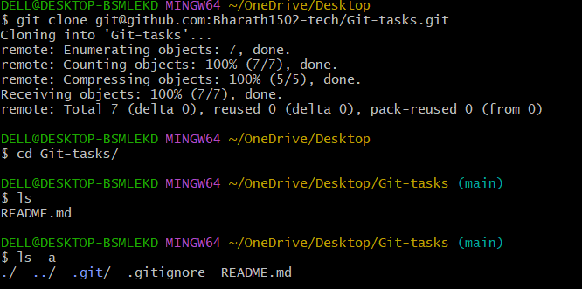

4 Create two files in local repo.
Created two files using “touch” command
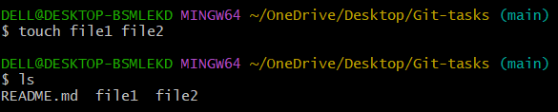

5. Commit two files and push to central Repository.
To commit the files which created use command “git commit -m “files created” “
Before that we have to check the “git status” so that we can check the untracked file and move them to tracked files.
To move them to tracked area use command “git add .”
After moving them to tracking area we can commit the created files.
After commit now push the created or modified files to central repo by using command “git push -u origin main(branch name)”.
Check in github repo the files will be added in that branch.
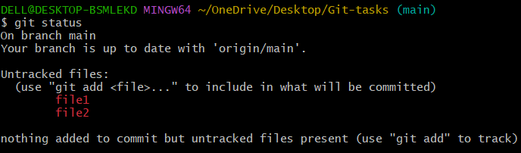
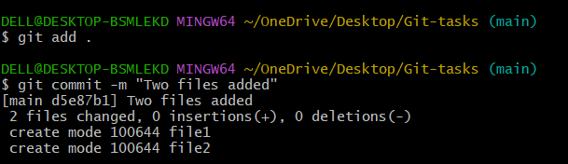
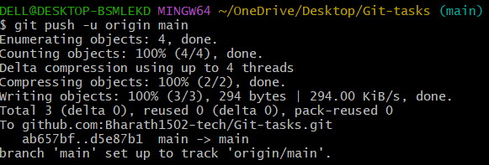
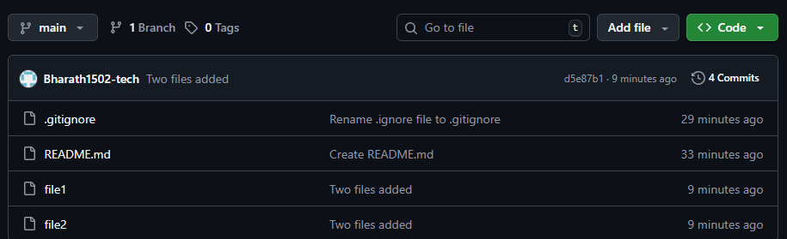

6. Create a branch in local and create a sample file and push to central.
To create a branch in local use command “git branch release(branch name)”
Change the existing branch to created branch by using command “git checkout release(branchname)”
Created a file in newly created branch with a name file3
Committed the created file by using command “git commit -m “message” “.
After commit, we have to push the changes to central repo by using command
“git push -u origin release (branch name)”.
Check the github so that the created branch and file will be pushed to central repo.
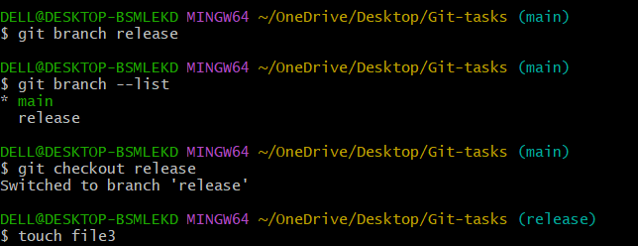
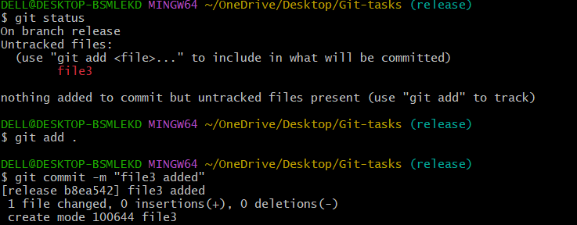
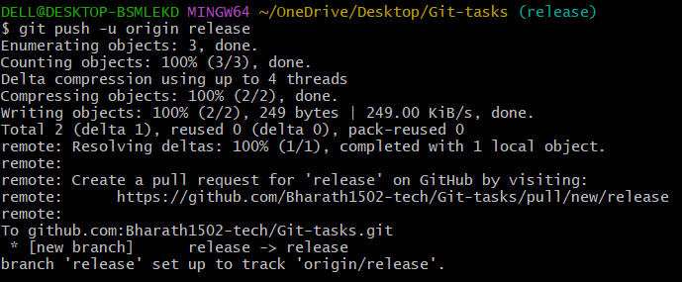
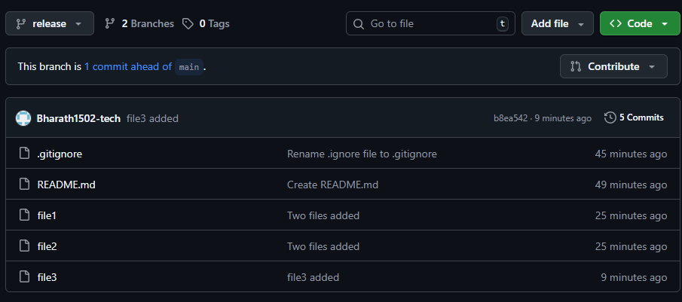

7. Create a branch in github and clone that to local.

Created a branch name “new-branch1” and added a file “newfile” in a github.
Colne that changes to local repo by using command “ git pull ”
Change the branch to newly created branch by using command “git checkout (branch name)”.
Check the lists in that branch so that newly created file will be shown.
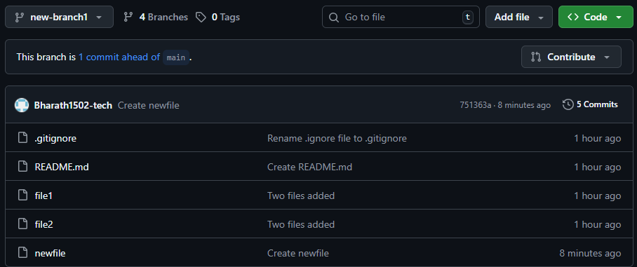
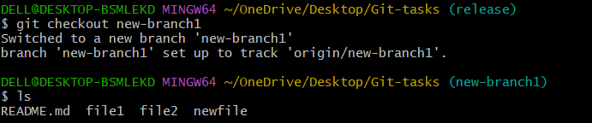
8. Merge the created branch with master in git local.
To merge to main branch, first we have to switch to main branch and use the command
“git merge (branch name)”. so that all the files will be copied to main branch.
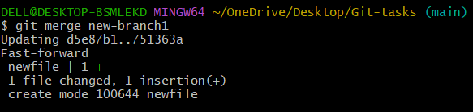
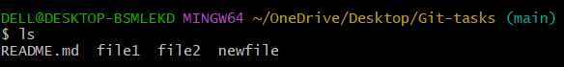

9. Merge the created branch with master in github by sending a pull request.
By using pull request we can merge the two branches from github.
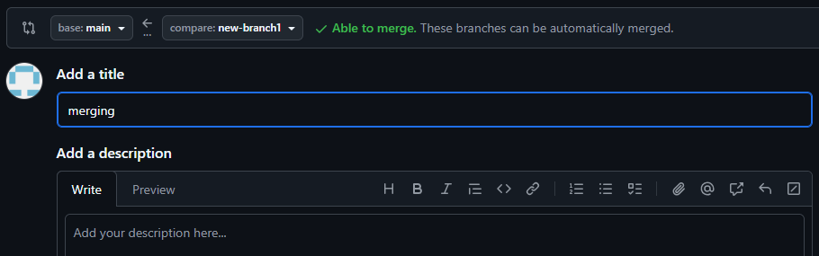



10. Create a file in local and send that to branch in github.
Created a file “f1” in local. And pushed the changes to central repo by using “git push” command.
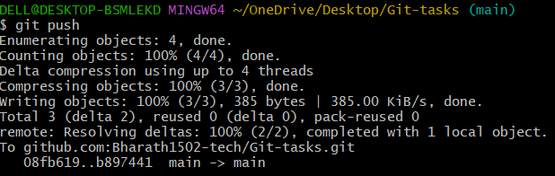
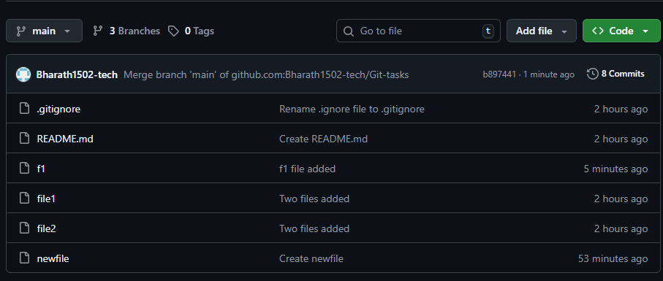

11. Clone only a branch from github to local.
Use command “git clone -b (branch name) ssh url”.
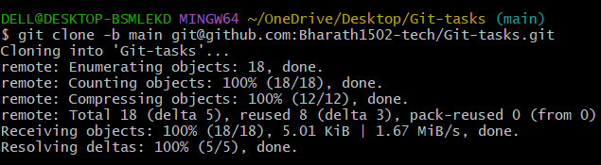

12. Create a file with all passwords and make that untrackable with git.
Create a file “password” and add some details in that file what we want to hide from others.
Then create “.gitignore” and add the file name what you want to hide.
Then add that .gitignore file and commit and push to central repo.
In github the .gitignore file will be shown and in that the hidden file will be show but the details in the file will be not show.
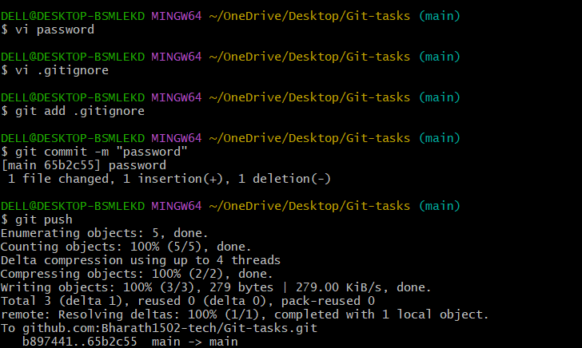
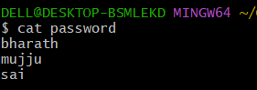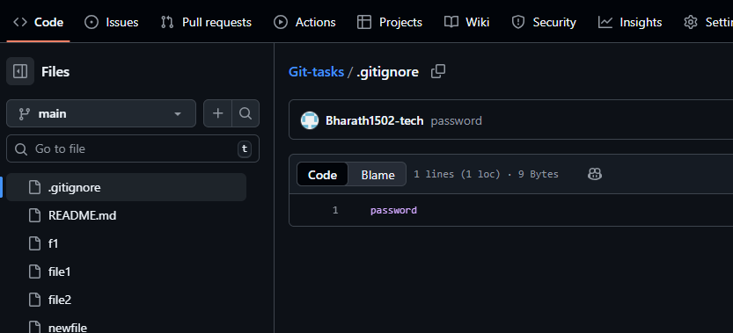

13. Make a commit and make that commit reset without savings changes.
Use “git reset” before commit the changes so that the files which are moved to tracked status will be get back to untracked status.
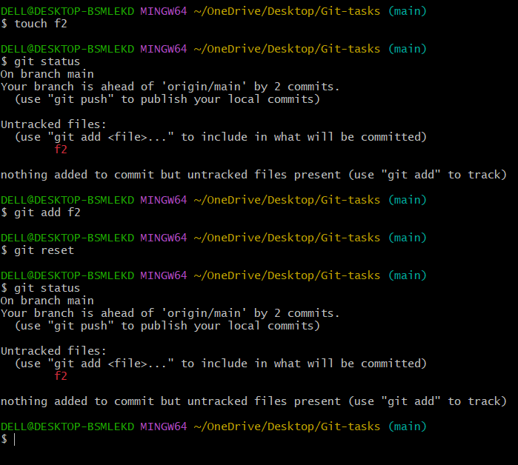

14 Revert a commited commit to the older version.
Use command “git revert (commit id)”. We can get back the deleted file to local repository.
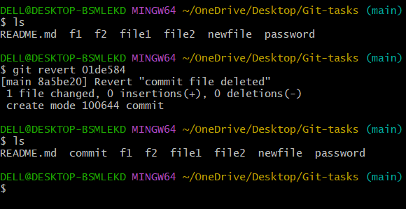

15. Push a file to stash without savings the changes and work on another file
16. Undo the stash file and start working on that again.

Use “git stash” command to move the file to stash memory, files which are in untracking area so that we can work on other file.
After working on other file again we can bring back the stash memory files to normal file for commit. For that use command “git stash pop”
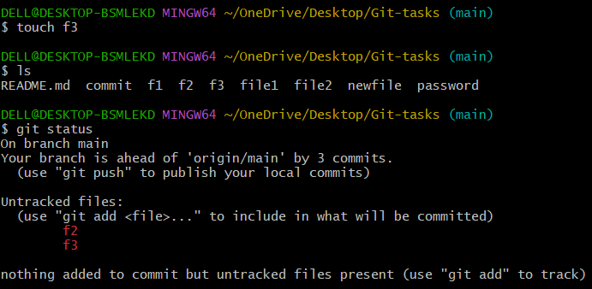
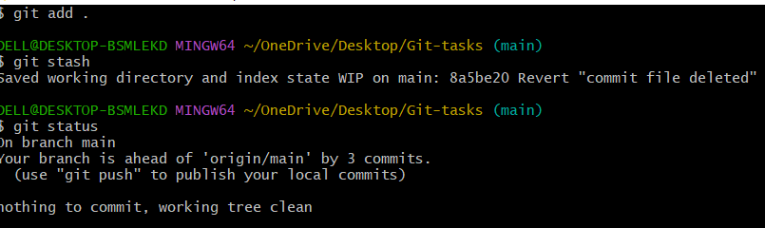
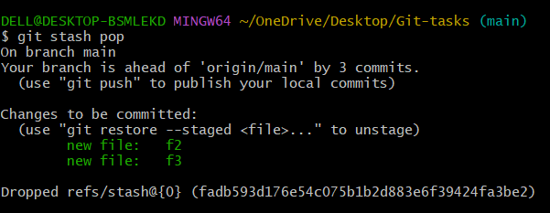

17. Generate a ssh-keygen and configure into github.

Use command “ssh-keygen” public key will be generated.
Use “cat keypath” to copy the public key and pate in github.
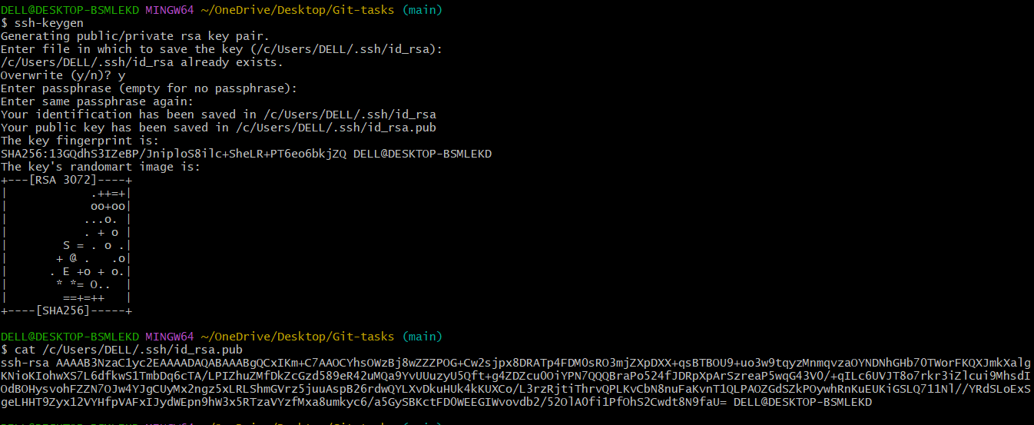

18. Configure webhooks to github.
19. Basic understanding of .git file.
Without .git we cannot commit and push the file or changes of the code to central repo.

20. Check all the logs of git.
Use command “git log” so that we can see all the git log commits
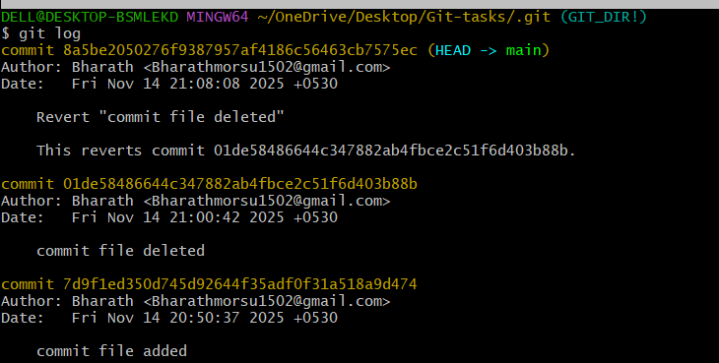
21. Rename the commit message
Use command “git commit –amend” we can change the commit message.
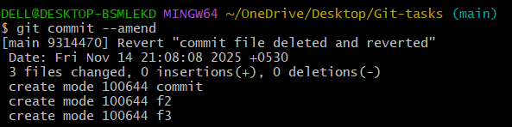s

22. Merge multiple commits into single commit.
Use command “git rebase -i HEAD~3” for merge the 3 commits.
